**Name: Ali Abid Chauhdary.**

**Class: Bscs 7-B .**

**Reg No: 213292.**

## **How to run files:**

**Task1:**

For task one place the index .html file in a folder named public in the root directory.

**Task2:**

For task 2 place the server.js and index.html file in the same directory. The reason is I was getting a strange error “path should be a string “ when I tried to place the index file in the public folder.

**Task3:**

For task 3 place the pug code in a new folder named views.

**TASK 1:**

**CODE:**

var express = require('express');

var app = express();

var bodyParser = require('body-parser');

var path = require('path');

app.use(express.static(path.join(__dirname, 'public')));

var urlencodedParser = bodyParser.urlencoded({extended: false});

app.use(bodyParser.urlencoded({extended:true}));

app.post('/uploadfile', urlencodedParser,function(req,res){

var fname = req.body.fname;

var lname = req.body.lname;

console.log("First name: "+fname);

console.log("Last name: " +lname);

console.log(req.body);

});

app.listen(8080);

**HTML:**

<!DOCTYPE html>

<html>

<body>

<form action="/submitform" method="post" target="_blank">

First name: <input type="text" name="fname"><br>

Last name: <input type="text" name="lname"><br>

<input type="submit" value="Submit">

</form>

<p>Click on the submit button, and the form will be submittied using the POST method.</p>

</body>

</html>

**OUTPUT:**

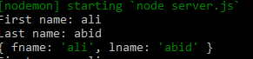

**TASK 2:**

**CODE:**

var express = require("express");

var multer = require('multer');

var app = express();

var storage = multer.diskStorage({

destination: function (req, file, callback) {

callback(null, './uploads');

},

filename: function (req, file, callback) {

callback(null, file.originalname);

}

});

var upload = multer({ storage : storage}).single('file');

app.get('/index.html',function(req,res){

res.sendFile(__dirname + "/index.html");

});

app.post('/uploadfile',function(req,res){

upload(req,res,function(err) {

if(err) {

return res.end("Error uploading file.");

}

res.end("File is uploaded successfully!");

console.log(req.body);

});

});

app.listen(8080,function(){

console.log("Server is running on port 8080");

});

**HTML:**

<!DOCTYPE html>

<html>

<body>

<h1>Show a file-select field:</h1>

<h3>Show a file-select field which allows only one file to be chosen:</h3>

<form action="/uploadfile" method = "post" enctype="multipart/form-data">

Select a file: <input type="file" name="file"><br><br>

<input type="submit">

</form>

</body>

</html>

**OUTPUT:**

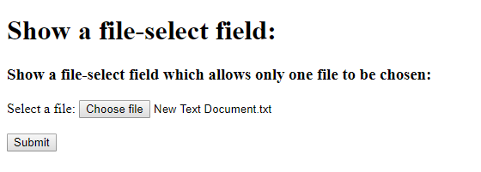

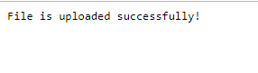

**TASK 3:**

**CODE:**

var express = require('express');

var bodyParser = require('body-parser');

var multer = require('multer');

var upload = multer();

var app = express();

app.get('/', function(req, res){

res.render('form');

});

app.set('view engine', 'pug');

app.set('views', './views');

// for parsing application/json

app.use(bodyParser.json());

// for parsing application/xwww-

app.use(bodyParser.urlencoded({ extended: true }));

//form-urlencoded

// for parsing multipart/form-data

app.use(upload.array());

app.use(express.static('public'));

app.post('/', function(req, res){

console.log(req.body);

res.send("recieved your request!");

});

app.listen(8080);

**pug:**

html

head

title Pug form

body

form(action = "/", method = "POST")

div

label(for = "fname") First Name:

input(name = "fname" value = "ALI")

br

div

label(for = "lname") Last Name:

input(name = "lname" value = "ABID")

br

div

label(for = "class") Class :

input(name = "class" value = "Bscs7-B")

br

button(type = "submit") Submit

**OUTPUT:**

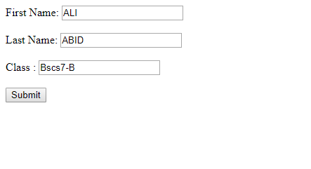

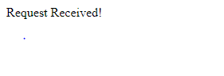



**Conclusion:**

This lab gave us a broad overview of express module. We learned how to handle form requests, file uploading and pug templates.